
KENBRIGHT ACTUARIAL AND FINANCIAL SERVICES LIMITED
DEFINED BENEFITS VALUATION MANUAL
INTERNAL TECHNICAL PROCEDURES
G | VERSION 1.0
 |  |  | JANUARY 2026
 |  |  | KAFS POLICY

Kenbright Actuarial & Financial Services Limited
26th Floor- Prism Towers – 3rd Ngong Avenue
P. O. Box 28281 – 00200
Nairobi, Kenya
kafs@kenbright.co.ke

 |  | 

DOCUMENT TRACKING
Revision History
Version | Author | Date | Revision
1.0 | Kenbright Actuarial and Financial Services Limited | January 2026 | Creation

Prepared for:

Kenbright Actuarial & Financial Services Limited
26th Floor, Prism Towers
3rd Ngong Avenue, Upperhill
P.O Box 28281 - 00200
Nairobi, Kenya

OUR REF
\\Kenbright\Internal Technical Procedures\Defined Benefits Valuation Manual

DOCUMENT PURPOSE
This document has been produced as part of the internal technical procedures for KAFS and provides guidance on valuation processes for Defined Benefit Calculations.

DOCUMENT OWNERSHIP
The owner of this document is Kenbright Actuarial and Financial Services Limited.
TABLE OF CONTENTS
1. TECHNICAL APPROACH 5
Technical Approach 5
Actuarial Valuation 5
Setting the Assumptions 5
Valuation Model 5
Calculating the Actuarial Liability 5
Assessing Financial (Solvency) Position of the Scheme 6
Reduction of Deficit (where observed) through a Remedial Plan 6
2. MODEL ANALYSIS 8
Intro tab 8
TDR 8
Input data 11
3. APPENDICES 12
Appendix 1: Sign-Off Template 12
4. APPROVAL 13

ABBREVIATIONS
NAME | DEFINITION
AVC | Additional Voluntary Contributions
DB | Defined Benefit
DC | Define Contribution
ERA | Early Retirement Age
IPP | Individual Pension Plan
KAFS | Kenbright Actuarial and Financial Services Limited
LRA | Late Retirement Age
NRA | Normal Retirement Age
RBA | Retirement Benefits Authority
SRBS | Staff Retirement Benefits Scheme
TDR | Trust Deed & Rules

TECHNICAL APPROACH

Technical Approach
Our approach to DB Actuarial valuation will be based on the following:

Actuarial Valuation

Setting the Assumptions
  - In the process of calculating an actuarial liability we will set out assumptions that will provide a best estimate of the future. These assumptions include: -
      - Mortality
      - Future Longevity (impact of living longer compared to mortality tables)
      - Inflation (Expense Inflation & Wage Inflation)
      - Investment Return on scheme assets
      - Discounting rate

Valuation Model
  - The actuarial model will be created using readily available data. The source of data will be primary data from published documents (e.g. mortality tables), data from The Scheme, government statistics and secondary data (e.g. investment income of bonds).
  - If factors outside the control of KAFS cause a delay/absence in provision of data necessary for development of the model, reasonable best estimate assumptions will be determined and disclosed in the report.

Calculating the Actuarial Liability
  - The actuarial liability will be valued using the attained age method.
  - This methodology entails first making an estimate of the projected benefits payable to each member in each future year based on the valuation assumptions. The actuarial liability as at the valuation date will be obtained using the valuation rate of discount.
  - The liability projection period will cover the entire expected liability term, based on members’ age profile.
  - The main aim of the valuation exercise will be to compare the value of assets as at the valuation date against the value of the liabilities to determine the financial solvency of the Scheme.

Assessing Financial (Solvency) Position of the Scheme
  - The Scheme can be in two possible solvency positions based on the relationship between the assets and the liabilities of the Scheme. The possible solvency positions are shown below.
  - The solvency position is also referred to as the minimum funding level – currently set at 100% by the RBA regulations.
  - The scheme may also be declared insolvent if it is unable to meet liabilities as and when they fall due. For example, assets which are not liquid (assets that cannot be sold in time to pay liabilities that are due).
  - Based on the solvency position of the Scheme, we will advise on the appropriate measures to be adopted.

Reduction of Deficit (where observed) through a Remedial Plan
  - The deficit of the scheme can be reduced in four ways: -
    - Reduce actuarial liability of the scheme: This may mean affecting the pension factors (if allowable) or definition of final salary.
    - Increase in scheme assets: Propose an asset liability matching structure that will enable the scheme to achieve a higher yield in the medium-to-long term. For example, younger members can have the portion of their assets invested in more volatile high-yield assets compared to members who are close to retirement.
    - Reduce scheme expenses: Scheme expenses and inflation in future expenses can reduce the deficit. For large schemes, the benefit of managing expenses may be marginal.
    - Sponsor injects assets into the scheme.
  - These possible remedial actions are illustrated in the figure below. It is worth mentioning that each action will be subject to legal & regulatory constraints and has been provided for illustrative purposes only.

MODEL ANALYSIS

Intro tab


  - Start by updating the highlighted dates on the intro tab
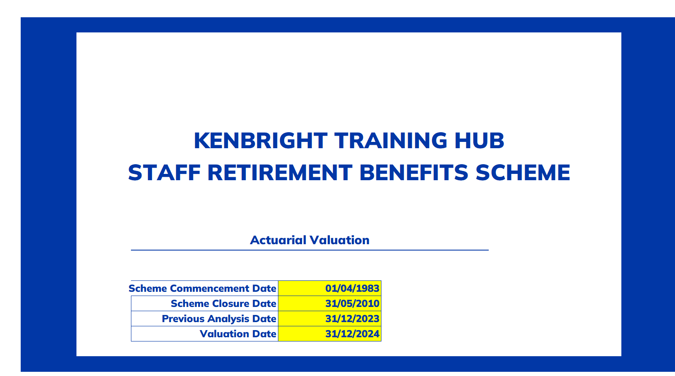

TDR

  - This tab should be updated with details from each clients Trust Deed and Rules (‘TDR’).
.Kenbright Training Hub Staff Retirement Benefits Scheme
Scheme Details as at 31 December 2024
Scheme Status
Scheme Commencement Date
Scheme Closure Date
Scheme Type
Normal Retirement Age – NRA - (years)
Early Retirement Age (years)
Contributions
Retirement Benefits
Pensionable Emoluments
Final Average Emoluments
Financial Year

  - 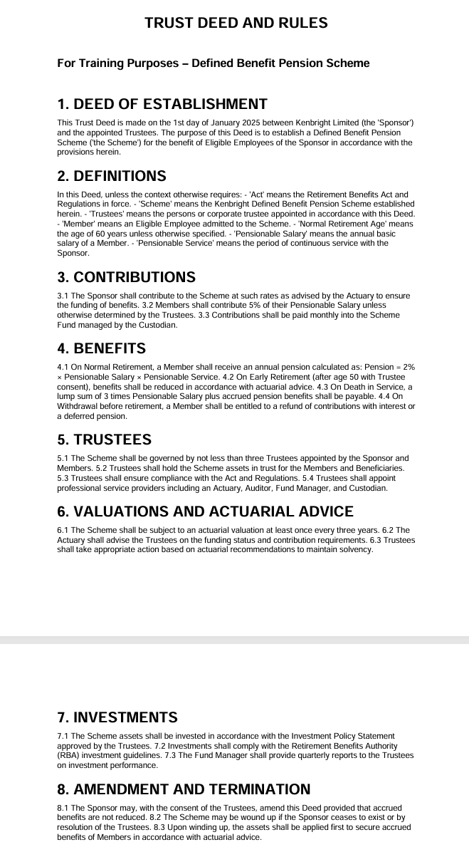
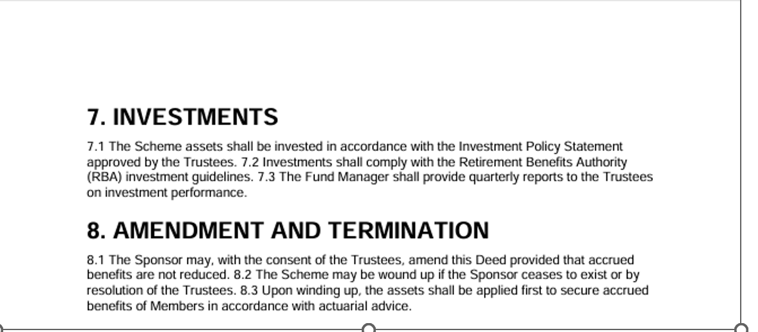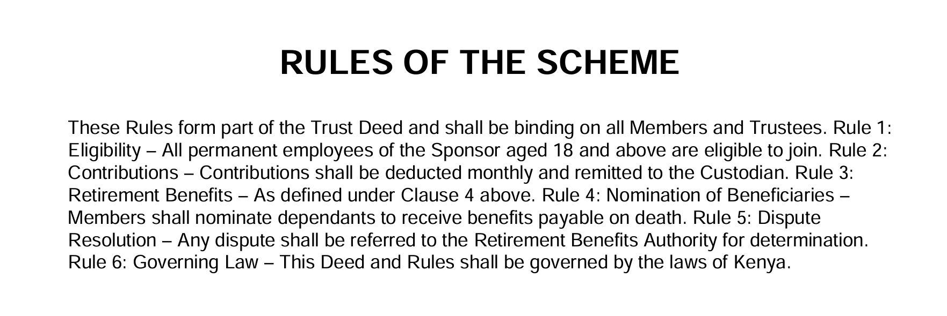

Input data
After cleaning the data and dp

APPENDICES

Appendix 1: Sign-Off Template

Sign-off
Statement by the Lead Analyst
I confirm that I have carried out this work in line with the applicable KAFS Internal Technical Policy and Procedure. Below is a summary of the key assumptions made:
Key Assumptions
1
2
3
4
5
Name:
Date:
Statement by Peer Reviewer
I have reviewed this work in line with the KAFS Work Review Policy and discussed all issues encountered with the Lead Analyst. Below are my review comments:
Review Comments
1
2
3
4
5
Name:
Date:
Statement by Supervisor
I have reviewed this work and discussed the issues encountered and the key assumptions made by the Lead Analyst. I confirm that the results are in order.
Name:
Date:

APPROVAL
Thus, adopted and signed by the management and Chief Actuary of KAFS in January 2026.
APPROVED BY
Ezekiel Macharia
Chief Actuary & Managing Director – Kenbright Actuarial and Financial Services Limited

Date: January 2026
Signed:



About Us

Kenbright Actuarial & Financial Services Limited (KAFS)
Prism Towers, 26th Floor
3rd Ngong Avenue, Nairobi
Kenya
www.kenbright.co.ke

Customer Service Lines: +254 (020) 22 111 52

Document Version

January 2026

Version 1.0: Creation

Reproduction – in total or in part – only with the permission of KAFS.

Key Contacts

E Macharia, FIA C.Act, FeASK
Chief Actuary & Managing Director
E-mail: ezekiel@kenbright.africa
Phone: +254 722 540 045

